Optimal Cards in Sealed
Mike Krzywicki
Now that the Invasion/Planeshift Sealed Deck Pro Tour Qualifier season is in full swing, if you have attended one, you have no doubt heard the following remark echoed throughout the side event area...
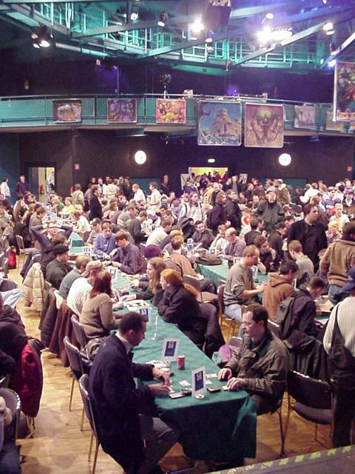
Over a thousand players built Sealed Decks at Grand Prix last weekend
"But my deck was great! How on earth did it lose?"
Usually this is followed by a quick rambling off of the contents of the deck, followed by that player's individual deckbuilding philosophy. Sealed deck philosophies vary wildly, some involving a set number of creatures, non-creature spells, and land, others going so far as to say "play all of your creatures" or "splash for all of your removal spells." Here are a few examples of these philosophies, from the StarCityGames.com Featured Article archive:
Rui Oliveira:
"I always stick to the same gameplan: 18 lands, 16 creatures, 6 tricks. That is the basic gameplan and I always try to get as close to it as I can. Normally the creature/trick ratio changes due to what the card pool gives me. I always play forty cards. I know that sometimes you want to go up a card or two, but by sticking to that rule I can minimize the temptation to play below-par cards."
Mary Van Tyne:
"I just have a few maxims for building Sealed decks, and they're really quite general. In fact, they're general enough to be common sense, and I won't spell them out in a neat little list for you. Basically, creatures and removal are good, eighteen creatures is an ideal number, and I like playing forty-one cards with seventeen lands."
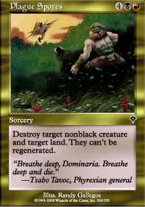
While these philosophies serve as solid guidelines, the mention of any specific numbers of creatures, non-creature spells, and land is quite a dangerous thing. Unlike Booster or Rochester Draft, in which you control your own destiny and card pool to a large degree, when you sit down to construct a freshly registered Sealed Deck, you are at the whim of the product you open. Each Sealed Deck card pool you receive should yield a different optimal build in direct relation to the contents of that card pool. For instance, what if you sit down to build and register your Invasion Sealed Deck, and open up something absurd like an Agonizing Demise, Plague Spores, an Annihilate, and five other sought-after creature removal spells in your card pool's deepest colors? Are you going to pass up the opportunity to play with all of these great spells just to meet a preimposed creature quota, or because you sat down with the understanding that you would play a certain color combination and not stray from that path? Hopefully not. Let's face it... if you have a "set-in-stone" Sealed Deck philosophy that would force you to play with a Vodalian Merchant over a choice removal spell, or that would encourage you to ignore powerful spells In a deep color in the product you open in favor of playing weaker spells in colors that you think are generally better, it probably deserves to be abandoned.

Brian Davis
The key to success in building Sealed Decks lies in approaching the situation with an open mind, and a good degree of experience with which to base deckbuilding decisions upon doesn't hurt matters. Take, for example, Brian Davis' Grand Prix-Amsterdam tournament report, available at Mindripper.com (Part 1, Part 2). For those of you who actively follow the Grand Prix circuit, you are most likely aware that most of the top Limited pros have a definite predisposition towards a single color combination in Invasion Sealed Deck. Red/Black/Blue has undoubtedly been the most popular color combination among the Magic elite this Grand Prix season, due in part to the sheer number of playable commons in those colors as opposed to those in Green and White, as well as the power of the cards available in those colors relative to those available in Green and White. The success of this color combination speaks volumes about its popularity in the pro Magic community; in the Sealed portion of Grand Prix-New Orleans, Red/Black/Blue was by far the dominant color combination, with each of those three colors occurring at least twice as much as Green and White in the top decks (for a complete recap of the Sealed portion of this event, visit here. But, in reading his report, you don't see Brian Davis toss Green and White out the door as soon as he opens his product, or limit himself by forcing a certain amount of creatures or non-creature spells into his deck. Instead, you see him carefully analyze the strengths and weaknesses of each of his colors, as well as the holes in his mana curve which would come about from the colors he eventually settled on, and, perhaps most importantly, recognition that there were several possible good builds out of his card pool, some of which would be more effective against certain opponents than others. Additionally, even after the Sealed portion of the event was completed, he still looked back at the product he worked with, debating whether or not the choices he made were optimal, despite the fact that he did quite well in that portion of the tournament. This type of candid objectivity and willingness to learn and improve is what separates the infrequent Pro Tour Qualifier attendee from the seasoned Magic professional.
Besides an open-minded approach, experience and intuition can also serve as great deckbuilding tools. In building a Sealed Deck, have you ever looked at a card that is generally highly regarded among the Magic community, but, quite simply, doesn't seem to fit in with the rest of your deck? This is where experience can come in handy. If you have had a reasonable amount of in-game experience with a card in a certain color combination, and you just aren't comfortable with it in the context of the deck you are trying to construct, don't play with it. Forget what everyone else thinks, because, in the end, you are the one who is going to be drawing that card all day while trying to break into the Top 8. Don't construe that statement as giving your peers' criticism a negative connotation, as such criticism can serve as a great learning tool in the future, but you should always make deck construction decisions that you feel good about, not that everyone around you thinks to be favorable.
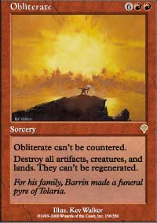
A great example of this type of thinking in the current Sealed season lies with one of the most popular rares out of the whole set, the red board-sweeper Obliterate. There is a maxim in what is generally considered to be common sense in Sealed Deck: mass removal spells are good. Period. Horrendous side effects notwithstanding, mass removal spells like Earthquake, Wrath of God, and Jokulhaups (Obliterate's older brother) have always been regarded as of the highest quality in Limited formats. And Obliterate is definitely a good card that deserves to be mentioned with the above cards. But, let's suppose you've opened an Invasion Sealed Deck that screams out Red/Black/Green. Among the better cards in your deck are a solid mana curve of creatures, like Serpentine Kavu, Pouncing Kavu, Yavimaya Barbarian and the like, and some solid removal like Plague Spores, Tribal Flames, and, of course, Obliterate. To prevent against adverse mana situations early in the game, in addition to providing much-needed mana acceleration for your larger creatures, you've chosen to include two Harrows and a Quiron Trailblazer. Now, while Obliterate might look like a great card when held up to the light by itself, in the context of this deck in particular, it would probably be a less than stellar choice for inclusion in the main deck. With a slew of good creatures, and, more importantly, mana acceleration that removes land from your deck to potentially draw after an Obliterate, that slot in your deck would probably be far better occupied by the lowly Slimy Kavu, since Obliterating in that style of deck puts you in a risky situation where you will most likely not be able to recover at the same pace as your opponent. Conversely, there are some aggressive decks that might not look like prime candidates for Obliterate, but, between the Invasion sacrifice lands and Dragon Attendants, could probably pull off the eight mana sorcery at a minimal mana commitment, and to devastating effect on the opponent's side of the board.
Looking back at Brian Davis' Grand Prix report, there is another excellent example of the application of this type of experience. If you look at Brian's card pool, then look at the final configuration of the deck that he ended up playing, you will note that he included Urborg Phantom in the final draft, while leaving the highly-touted Soul Burn out, with eight Swamps in his deck to boot! Take a good look at Soul Burn. It is damage-based creature removal, direct damage, and life-gain all rolled into one. It is one of the more powerful cards in the set, and a universally high draft pick in Booster and Rochester Draft formats. Now look at Urborg Phantom. Low toughness, an ability of negligible quality that almost never gets activated, and it can't even use its one redeeming feature, that being its three power for three mana, to trade with a better creature because it can't even block! The Phantom is typically regarded as a filler card, with its one true home found in B/U decks full of Repulses, Recoils, and other goodies, and you can usually pick them up in Draft very late. So why on earth did he put the Phantom in his deck over a Soul Burn? Simple. He, as most Magic Pros do, realizes that the goal in building a Sealed Deck, and, for the most part, a Magic deck in general, is not to have a deck full of amazing cards that have flashy effects on the game, but rather to deal twenty points of damage to his opponent while keeping his own life total above zero. The Soul Burn, if included in that deck, could often sit in his hand with little or no potential effect on the game. Of course, in some games it would be devastating, either destroying a large creature and gaining a significant amount of life in the process, or just outright ending the game by targeting the opponent but, unless at least half of the Swamps in the deck are drawn, it won't accomplish much of anything. The Phantom, however, provides an early threat, which, unchecked, can quickly have his opponent backpedaling. It helps to fill out the three-mana slot in his mana curve, and, at the very worst, it will force his opponent to block and trade with a creature that they thought enough of to include in their deck. Obviously, the decision is up for debate, but, in this case, Brian Davis built a deck that he was comfortable with, and had great results with it. A deck full of great cards doesn't always make for a great deck, and, similarly, a well-built deck full of mediocre and above average cards doesn't always make for a mediocre to above-average deck. The trick is finding the synergy in the product laid before you, and every Sealed Deck yields different synergies, different strengths, and different weaknesses.
Try not to limit yourself when approaching Invasion/Planeshift Sealed Deck; in some cases, the card pool will do that for you, and, if you're going against the grain of what you've been given to play with, you'll be in for a long, tough day of Swiss Rounds. Various philosophies on deckbuilding can serve as good guidelines, but don't apply them too rigidly to your deckbuilding decisions. Such precepts can often lead you away from your product's best build, and that's exactly what you should be spending your deck construction time working towards. Keep an open mind, be confident in your decisions, and you just might end up in Barcelona playing with the game's best and brightest.

